**Forts:**

Derawar Fort

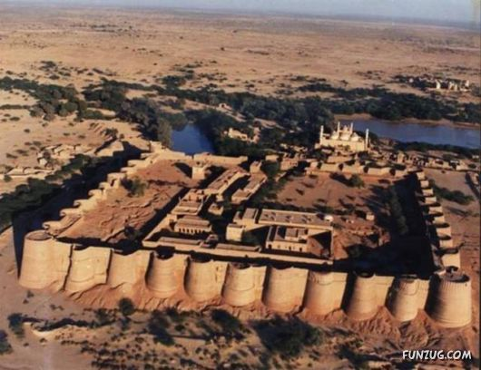

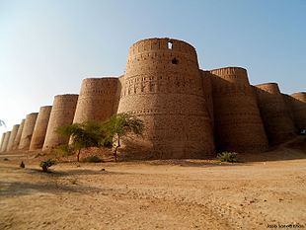

**Derawar Fort** is a large square fortress in Yazman Tehsil, Punjab, Pakistan. Approximately 130 km south of the city of Bahawalpur, the forty bastions of Derawar are visible for many miles in the Cholistan Desert. The walls have a perimeter of 1500 metres and stand up to thirty metres high. Derawar fort was first built in the 9th century AD by Rai Jajja Bhatti, a Hindu ruler of the Bhatti clan, as a tribute to Rawal Deoraj Bhatti, the king of Jaisalmer and Bahawalpur. The fort was initially known as *Dera Rawal*, and later referred to as *Dera Rawar*, which with the passage of time came to be pronounced *Derawar*, its present name. In the 18th century, the fort was taken over by Muslim Nawabs of Bahawalpur from the Shahotra tribe. It was later rebuilt in 1732 by Abbasi rulers Nawab Sadeq Muhammad, but in 1747 the fort slipped from their hands owing to Bahawal Khan's preoccupations at Shikarpur. Nawab Mubarak Khan took the stronghold back in 1804. 1,000 year-old catapult shells were found in the debris near a decaying wall in the fort.